Finding cool ideas – A step-by-step how-to guide
By Rhea Wessel

Step 1: Use high-quality publications and general search terms

When doing desk research, I tend to gravitate to high-quality general publications as a starting place, and then I narrow into specialty publications and trade magazines.

Once I was asked to come up with story ideas related to water problems in India.

I started with a basic keyword search in Scientific American when I began the assignment.

I found this article:



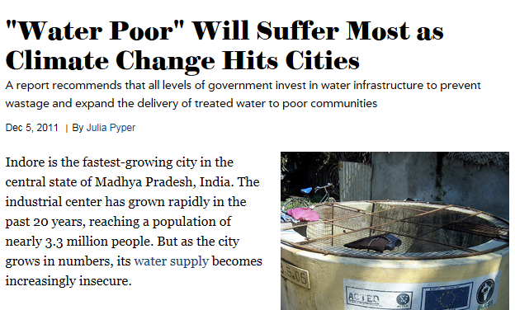

I found some interesting ideas and came across new keywords that I searched in another step. These include: "water threats," "water poor," and "over-tapping groundwater."

To keep track of my work - and to make it easier to share with team members - I keep lists of searches already performed, publications already searched, and searches still to do. My lists can look like this:

Keywords already searched
"water threats"
"water poor"
To Search
"climate change" and "water levels"

Over-tapping groundwater
Overexploitation

"fetch water"
Water hygiene
Water and privatization
Land tenure rights

Step 2: Look in the wrong spot for new ideas

As I peruse material, I intentionally look in the "wrong" publication for my research subject. In other words, I look in magazines of high-quality apart from the usual suspects.

For instance, I searched Wired on the hunch that two hot topics might be linked: "big data" and "water." Hmmm, sure enough...

I found this article:


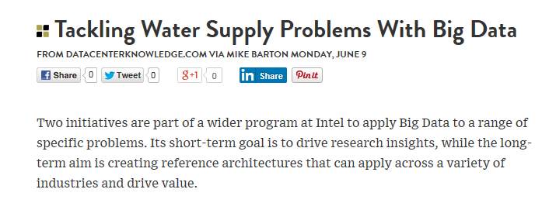

Likewise, I wanted to know what was in Foreign Affairs related to water infrastructure.

I found this article:


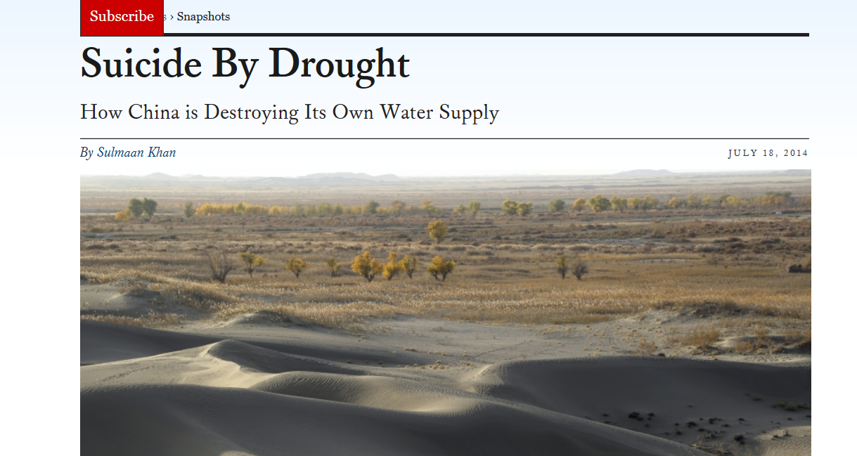

The Foreign Affairs article "Suicide by Drought" got me thinking about a mammal called the pika that burrows through the ground leaving holes that capture water and prevent soil erosion. The article says they were exterminated in mass in China, and this led to falling water levels.

I might not be able to tie this back to challenges in India, but I've now found something interesting for sure, and I've learned about how China's rapid economic growth has led to haphazard water infrastructure. I will save the anecdote about pikas in China as an idea for a nice lead for a story, or perhaps we could use it in video in some way.

Step 3: Mindmap your ideas based on your fresh inspiration; begin filling out a story plan

Next I might begin filling out a Story Plan or creating a mind map of related topics. I did a bit more general searching on "challenges" and "water infrastructure" and quickly scribbled the below mindmap, which I later put into PowerPoint:

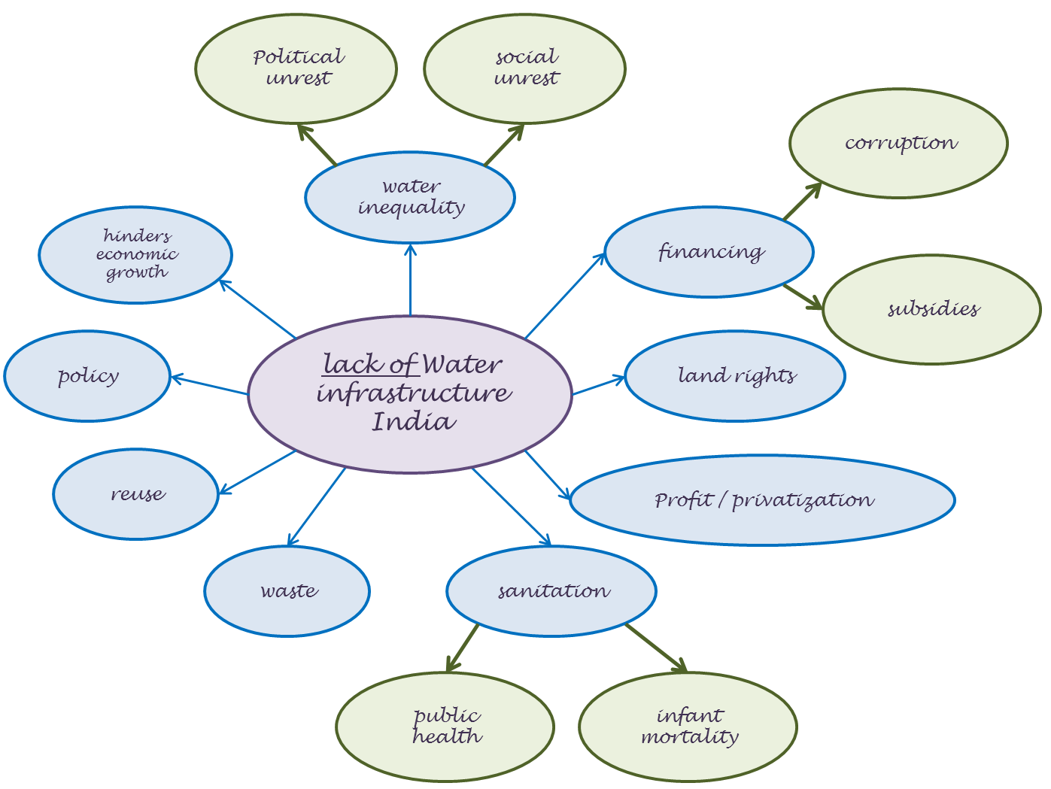

Here you'll see terms as diverse as regulation, corruption and political unrest.

In the brainstorming phase, one shouldn't hold back. This is where the wild ideas belong.

Step 4: Capture ideas for later; capture visual material

Another thing I do is capture what grabs my eye so that I may be able to use it in one way or another down the road.

I try to collect my materials and store them in a way so they can be accessed by all project members, and I can return to them after a break and remember where I left off.

If I find a telling statistic, I've got a place to keep that; if someone's ideas and writings catch my eye, I have a place to write down the name as a possible interview partner.

Also, I realize that for social media, it always needs to be visual. I happened across the two slides below. The first has an interesting quote. The second could inspire new visuals.



